
UNITAS The Journal of the Knights of St Columba in Glasgow

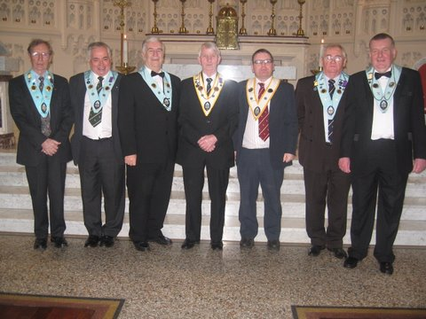
Newly Installed Provincial and Council Officers for 2010/2011 in St Alphonsus Church on March 26th.

Coming Up in the Life of the Knights

• Fraternal Cross Handover Sunday 16th May in St Alphonsus Calton at 12 Noon

90 Years of Service

SERVE GOD BY SERVING OTHERS

At a meeting held in Glasgow on 5th October 1919; attended by twenty-four Catholic gentlemen; Cork man Patrick J. O'Callaghan asked those present to agree to the formation of a new organisation, which would ultimately be called the Knights of St. Columba. This proposal was agreed and a further meeting was convened. The new Order was to be modeled, as far as was practicable, on the example of the Knights of Columbus in the USA (founded by Fr. Michael J. McGivney)
90 years on the order still fulfils its original ideas of Charity Unity and Fraternity. Applying these virtues to assist the church and the wider community.

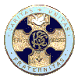
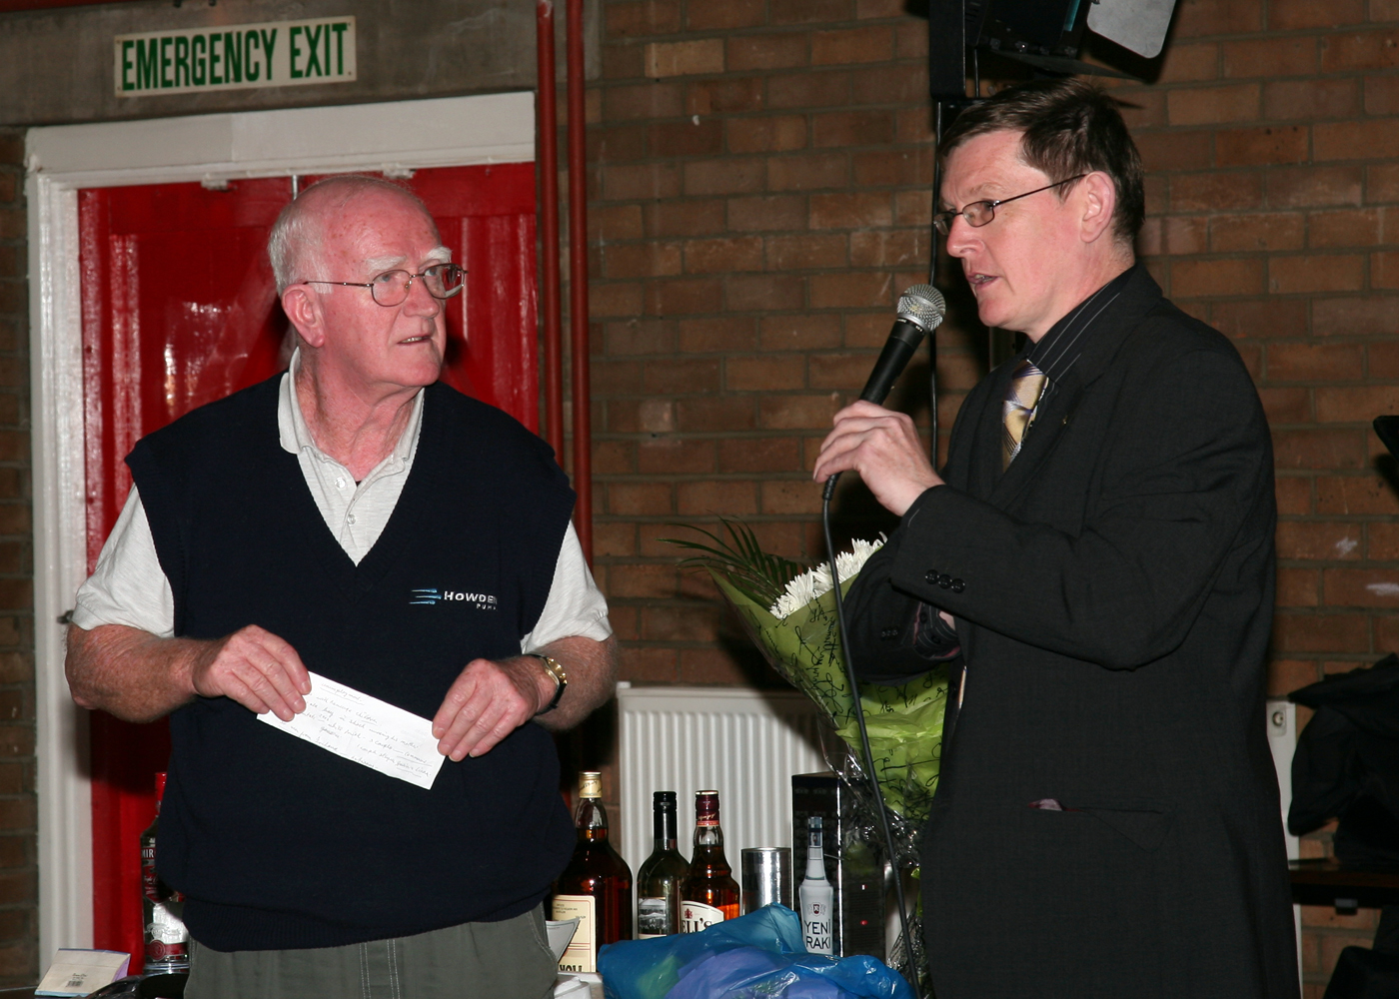

Knights in Action

Over the past year Knights from all over the city have shown their commitment to our virtue of Charity by raising large sums of money for very important causes.
Council 396 recently raised £1000 for an orphanage in South Africa for children who have lost their parents to the scourge of Aids. After taking part in a sponsored walk they presented a cheque to Father Eunan who runs the project.
In other parts of the city Council 8 Clydebank continue the good work for the Sisters of Gospel Life donating to the various activities associated with The Cardinal Winning Pro-Life initiative.
Council 603 Kirkintilloch continue to fund and assist a Soup Kitchen for the homeless in Glasgow at weekends.
Council 22 have also been active in assisting various charities in the City.

…..

Grand Knight of Council 396, Brother Tony McCartney presents Father Eunan with a cheque for £1000 for Franciscan Orphanage in South Africa

April 2010 ● Volume 1, Issue 4 ●KSC Glasgow 07852 309493

Another Special Year

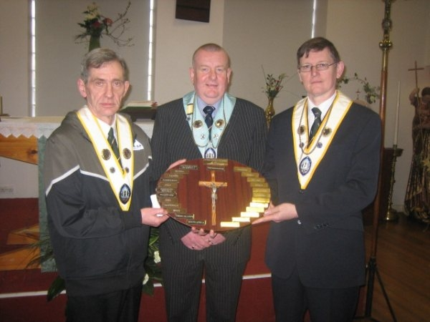

As the order concludes its 90th Anniversary celebrations of its founding, our own Province 1 Glasgow begins marking our own 90th birthday. The Province was founded on June 26th 1920 and is the oldest in the order. To celebrate this milestone the National Fraternal Cross of the order is being taken around the parishes of the Archdiocese. The journey began at our Deceased Brothers Mass in November and will continue culminating in a Special Mass to be held in St Mary’s Pro-cathedral and celebrated by His Grace Archbishop Conti on Sunday 27th June next year.
The journey continues with the next handover taking place in St Alphonsus on Sunday 16th May where Council 2 receive the Cross. From Council 4.

You are all welcome to be part of the journey.

Fraternal Cross Handover in Blessed John Duns Scotus from Council 598 Penilee to Council 396 Kings Park

Charity, Unity, Fraternity

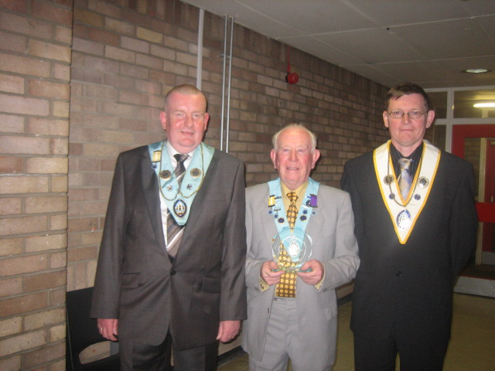

Do you want to know more about or join the Knights of St Columba?
Please contact us :

Head Office
0141 883 5700

Province 1
07852 309493

Web Site
www.ksg.org.uk

The Order is open to all Catholic Men over the age of 16

The Knights of St Columba
The Catholic Lay Mans Order

Brother George White receives an award for 40 years service to the Knights of St Columba

Street Address

Page 2
April 2010● Volume 1, Issue 4 ● KSC Glasgow 07852 309493

